Tab 8
NAME:S.KAVIDHARSHINI
E-MAIL: kavidharshni050308@gmail.com
College:V.S.B.college of engineering technical campus
—----------------------------------------------------------

Automated Billing System

Problem Statement:
Manual billing processes are time-consuming and prone to errors. Businesses need an automated system to generate bills quickly, calculate totals accurately, and maintain transaction records efficiently. The Automated Billing System helps reduce manual work and improves billing accuracy.



Tab 1
Objective:
- Automate bill generation.
- Reduce calculation errors.
- Maintain customer and transaction records.
- Generate accurate invoices quickly.
- Improve business efficiency.



Tab 2
Scope:
- Customer information management.
- Product management.
- Automatic bill generation.
- Tax calculation.
- Receipt generation.
- Sales record maintenance

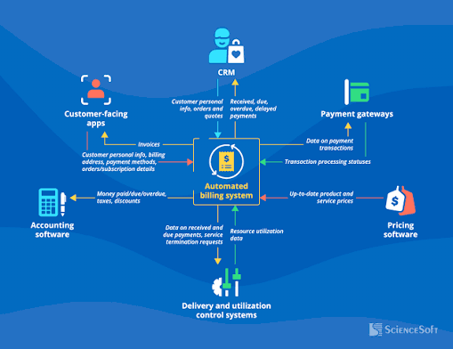

Tab 3
Requirement:
1.Hardware Requirements:
- Processor: Intel Core i3 or above
- RAM: 4 GB minimum
- Storage: 20 GB free space
2.Software Requirements
- Operating System: Windows/Linux
- Programming Language: Python
- Database: MySQL
- IDE: VS Code/PyCharm
- Browser (for web version): Chrome/Firefox

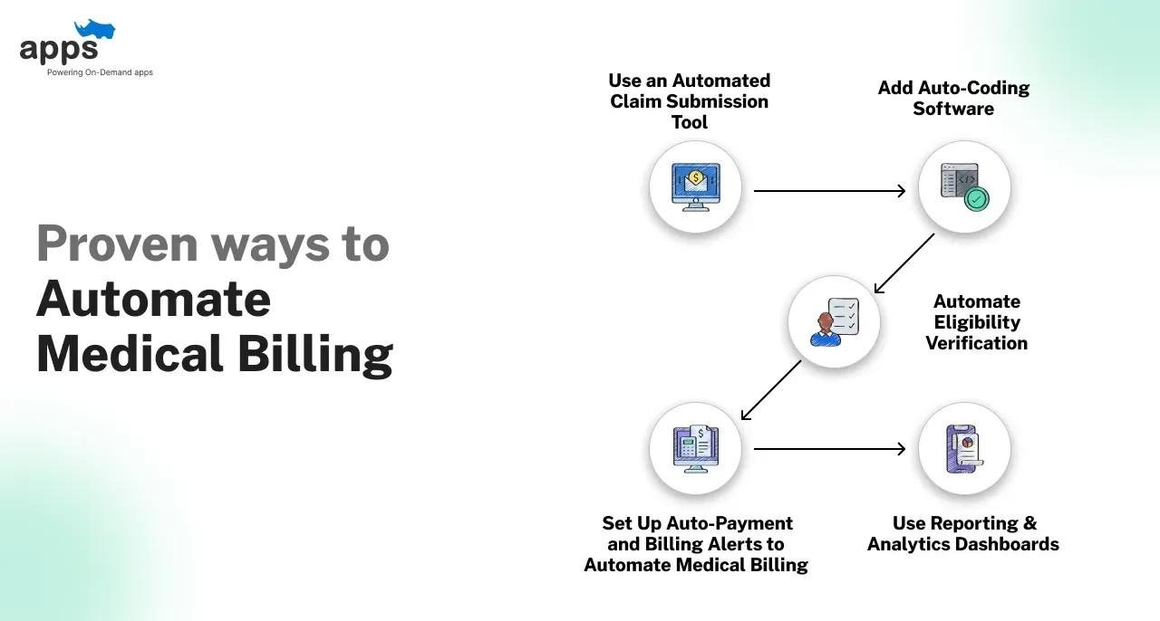

Tab 4
System Design:
Modules
- User Login Module
- Customer Management Module
- Product Management Module
- Billing Module
- Payment Module
- Report Generation Module

Input
- Product Name
- Quantity
- Price

Process
- Calculate Total Amount
- Calculate Tax
- Generate Final Bill

Output
Printed/Digital Invoice
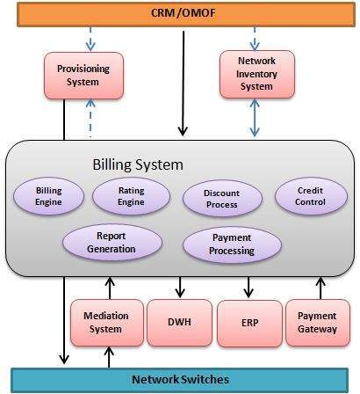

Tab 5
Implementation:
- Created a user-friendly billing interface.
- Stored product and customer details in the database.
- Implemented automatic total calculation.
- Added tax calculation functionality.
- Generated invoices automatically.
- Stored transaction history for future reference.
- Tested the system with different billing scenarios.

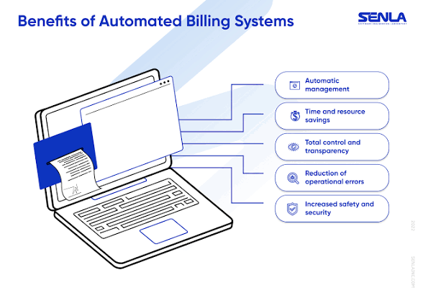

Tab 6
Testing:

Test Case 1
- Input: Product Price = ₹100, Quantity = 2
- Expected Output: Total = ₹200
- Result: Passed

Test Case 2
- Input: Product Price = ₹150, Quantity = 3
- Expected Output: Total = ₹450
- Result: Passed

Test Case 3
- Input: Invalid Quantity
- Expected Output: Error Message
- Result: Passed

Tab 7
Problem:
Generate a bill automatically by calculating total amount and GST.

Python code

product_name = input("Enter Product Name: ")
price = float(input("Enter Product Price: "))
quantity = int(input("Enter Quantity: "))

total = price * quantity
gst = total * 0.18
final_amount = total + gst

print("\n----- BILL -----")
print("Product:", product_name)
print("Price:", price)
print("Quantity:", quantity)
print("Total:", total)
print("GST (18%):", gst)
print("Final Amount:", final_amount)

Output
Enter Product Name: Pen
Enter Product Price: 10
Enter Quantity: 5

----- BILL -----
Product: Pen
Price: 10.0
Quantity: 5
Total: 50.0
GST (18%): 9.0
Final Amount: 59.0

Tab 9
Program Explanation:
- The user enters the product name, price, and quantity.
- The program calculates the total amount using:
- Total = Price × Quantity
- GST is calculated at 18%:
- GST = Total × 18 / 100
- Final Amount is calculated as:
- Final Amount = Total + GST
- The bill is displayed with all details.

Output Explanation:

For the product Pen:
Price = ₹10
Quantity = 5

Total Amount:
10 × 5 = ₹50

GST:
18% of 50 = ₹9

Final Amount:
₹50 + ₹9 = ₹59
Therefore, the final bill amount is ₹59.

Tab 10
Future Enhancements:
- Barcode scanner integration.
- Online payment gateway support.
- Inventory management system.
- PDF invoice generation.
- Customer purchase history tracking.
- Mobile application support.
- Cloud database integration.

Results:
- Bills were generated automatically.
- Tax calculations were accurate.
- Invoice generation time was reduced.
- Transaction records were maintained successfully.
- The system improved billing efficiency.

Conclusion:
The Automated Billing System successfully automates the billing process by generating invoices, calculating taxes, and maintaining transaction records. It reduces manual effort, saves time, and improves billing accuracy.
